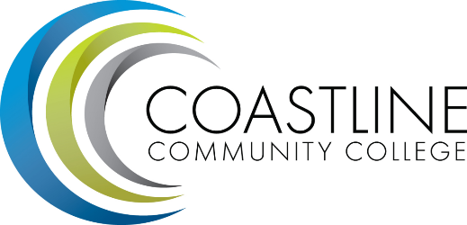

CMT 2016-17 Accomplishments
DRAFT

Fall 2016
- Completed all Program and Department Reviews
- Finalized the Wing Planning

Spring 2017
- Met regarding pathways (ACM)
- Participated in IEPI
- Approved the Mission Statement

